
C PROGRAMMING ASSIGNMENT

Student Name | JANANI P
Register Number | 1912260382
Course Code & Name | CSA0210 & C - PROGRAMMING
Slot | SLOT - C
Assignment / Task Title | CO – 1 & ASSIGNMENT - 2
GitHub Repository URL
Submission Date | 28 / 10 / 2026

Instructions to Students
- Complete every section for each assigned task.
- Write your own explanation, algorithm/pseudocode, and program.
- Run the program and insert a clear screenshot of the output.
- Include test cases and a short analysis where applicable.
- If code is maintained on GitHub, provide the correct repository link.

TASK 1 — [ORGANISE THE PROGRAM WITH HEADER FILES]

Task / Problem Statement
To organise the electricity billing program using header files and conditional compilation.

Aim
To use header files and DEBUG mode in C programming.

Concept / Theory
Header files contain constants and function declarations. Include guards prevent repeated inclusion. "#ifdef DEBUG" is used to display debugging messages.

Procedure / Algorithm
1. Start the program.
2. Include the header file.
3. Define constants and functions.
4. Calculate the electricity bill.
5. Display the result.
6. Stop the program.

Program / Source Code
#include <stdio.h>
#define RATE 5
#define FIXED_CHARGE 50
int main()
{
int units = 100;
int bill = units * RATE + FIXED_CHARGE;

#ifdef DEBUG
printf("Units: %d\n", units);
printf("Bill: %d\n", bill);
#endif

printf("Electricity Bill: Rs. %d\n", bill);

return 0;
}
Output Screenshot
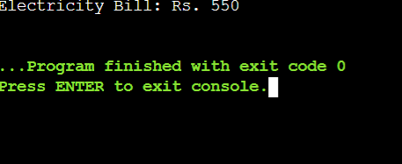

Analysis / Discussion
- Header files organise the program.
- Include guards prevent repeated inclusion.
- "#ifdef DEBUG" displays debugging information.
- Time complexity: O(1).
- Space complexity: O(1).

Result
Thus, the program was organised using header files and conditional compilation in C programming.

TASK 2 — [Read and Print Data Correctly]

Task / Problem Statement
To write a C program to read electricity units from the user, calculate the bill amount, and display the result using suitable format specifiers.

Aim
To read and display electricity billing details correctly using scanf() and printf() in C.

Concept / Theory
C uses format specifiers to read and print different data types. Correct format specifiers help avoid errors and display billing amounts accurately.

Procedure / Algorithm
1. Start the program.
2. Declare the required variables.
3. Read input using scanf().
4. Check the return value of scanf() for valid input.
5. Calculate the electricity bill.
6. Display the bill using printf().
7. Stop the program.

Program / Source Code
#include <stdio.h>
int main()
{
int units;
double bill;
printf("Enter units: ");
if (scanf("%d", &units) != 1)
return 1;
bill = units * 2.25 + 50;
printf("Bill: Rs %.2f\n", bill);
return 0;
}

Output Screenshot
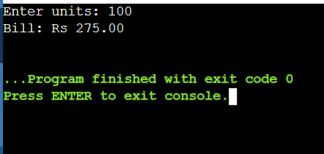

Analysis / Discussion
- %d is used for int, %u for unsigned int, %ld for long, %lld for long long, %f for float, %lf for double in scanf(), %c for char, and %s for strings.
- Using an incorrect format specifier may cause undefined behaviour.
- The return value of scanf() helps detect invalid input.
- Rupees and paise can be printed using printf("Rs %ld.%02ld", p/100, p%100).
- Reading input using fgets() and converting it with sscanf() or strtol() can improve input validation.
- Time complexity: O(1).
- Space complexity: O(1).

Result
Thus, data was read and printed correctly using suitable format specifiers, and electricity billing details were displayed successfully using C programming.

TASK 3 — [Control Type Conversion and Precision]

Task / Problem Statement
To write a C program to calculate the electricity bill using different data types and analyse implicit conversion, integer division, explicit casting, and rounding errors. Demonstrate at least three unexpected results caused by type conversion and explain how to avoid them.
Aim
To understand type conversion and precision in C programming and perform calculations accurately.
Concept / Theory
Type conversion is the process of changing one data type into another. C supports implicit conversion and explicit casting. Integer division removes the decimal part, while floating-point division gives decimal results. Precision is important for accurate calculations.

Procedure / Algorithm
1. Start the program.
2. Declare the required variables.
3. Read the electricity units.
4. Calculate the bill using suitable data types.
5. Demonstrate implicit conversion and explicit casting.
6. Display the results using printf().
7. Stop the program.

Program / Source Code
#include <stdio.h>
int main()
{
int units = 100;
int a = 5, b = 2;
long int large = 123456789L;
double bill, total;
bill = units * 2.25 + 50;
printf("Integer division: %d\n", a / b);
printf("Floating-point division: %.2f\n", (double)a / b);
printf("Casting long to int: %d\n", (int)large);
total = units * 2.25 + 50
printf("Bill amount: Rs %.2f\n", bill);
printf("Total amount: Rs %.2f\n", total);
return 0;
}
Output Screenshot
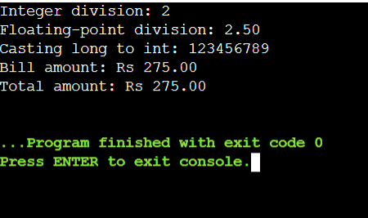

Analysis / Discussion
- Implicit conversion changes a data type automatically during calculation.
- Explicit casting converts a value into a specified data type.
- Integer division gives only the whole-number result. For example, 5 / 2 gives 2.
- Floating-point division gives decimal results. For example, 5.0 / 2 gives 2.5.
- Converting a floating-point value to int removes the decimal part.
- Using double helps to perform decimal calculations with better precision.
- Incorrect type conversion may cause unexpected results.
- Rounding should be done carefully to avoid calculation errors.
- Time complexity: O(1).
- Space complexity: O(1).

Result
Thus, type conversion and precision were studied successfully using C programming. Implicit conversion, explicit casting, integer division, and rounding were understood.

TASK 4 — [Trace the Compilation Process]
Task / Problem Statement
To trace a C program through the stages of compilation using GCC and understand preprocessing, compilation, assembly, and linking.
Aim
To understand the different stages of compilation in C programming and identify errors and warnings.

Concept / Theory
C programs pass through four main stages before execution.

1. Preprocessing
2. Compilation
3. Assembly
4. Linking

Procedure / Algorithm
1. Start the program.
2. Write the C program and save it as bill.c.
3. Run the preprocessing stage.
4. Run the compilation stage.
5. Run the assembly stage.
6. Link the object file to create an executable.
7. Execute the program.
8. Observe the output.
9. Stop.

Program / Source Code
#include <stdio.h>
int main()
{
int units = 100;
double bill;
bill = units * 2.25 + 50;
printf("Electricity Bill: Rs %.2f\n", bill);

return 0;
}
Output Screenshot
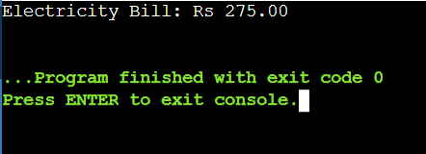

Analysis / Discussion
If a program is divided into multiple source files, each file can be compiled separately. When one file is changed, only that file needs to be recompiled before linking.
This saves compilation time in large programs.
Time Complexity: Depends on the size of the program.
Space Complexity: Depends on the size of the generated object files.

Result
Thus, the compilation process of a C program was traced successfully. The stages of preprocessing, compilation, assembly, and linking were studied, and the differences between errors and warnings were understood.

Test Cases / Validation Table
Record different inputs, expected results, actual results, and whether each test passed.
Test No. | Input / Scenario | Expected Output | Actual Output | Status
1
2
3
4
5

Final Submission Checklist
☐ Student and course details completed
☐ Task statement, aim, theory, and algorithm included
☐ Program code is readable and runs successfully
☐ Output screenshot included
☐ Analysis and result written in own words
☐ Test cases completed where applicable
☐ GitHub repository link added if required

